- Using the mongoimport tool, create the database “companies” by loading the documents found in the “companies.json” file into the “research” collection.
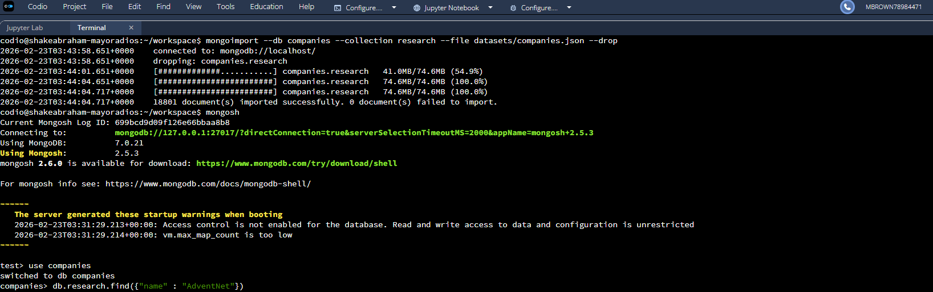
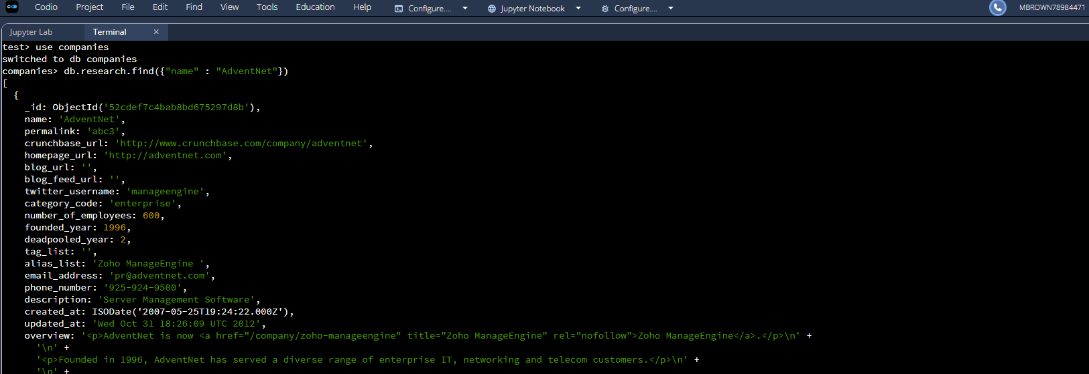
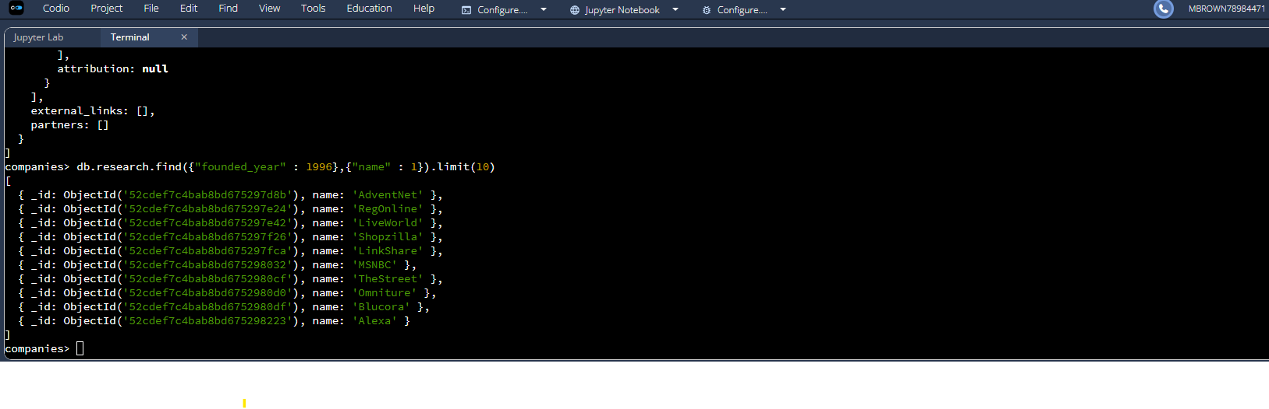

- Perform the following tasks using MongoDB queries:
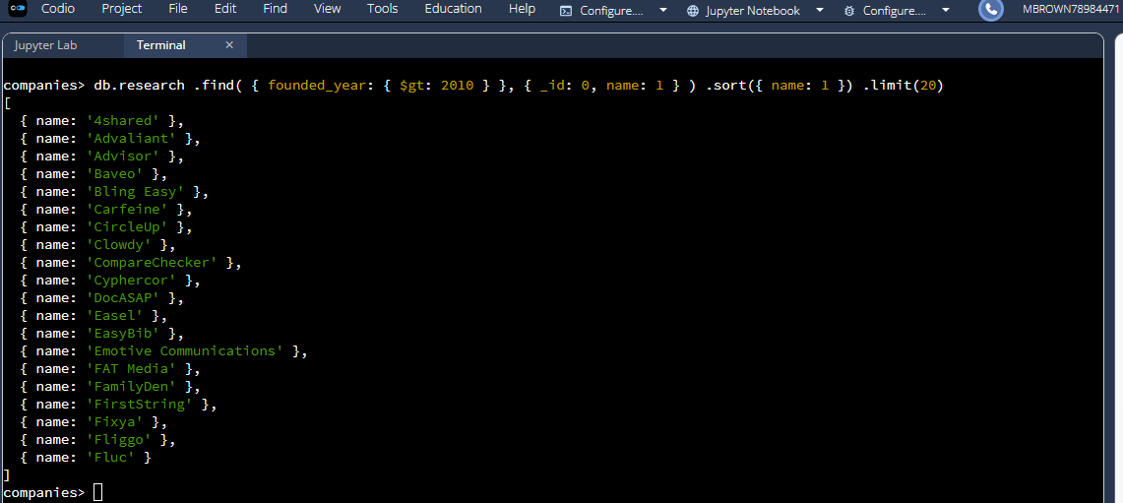
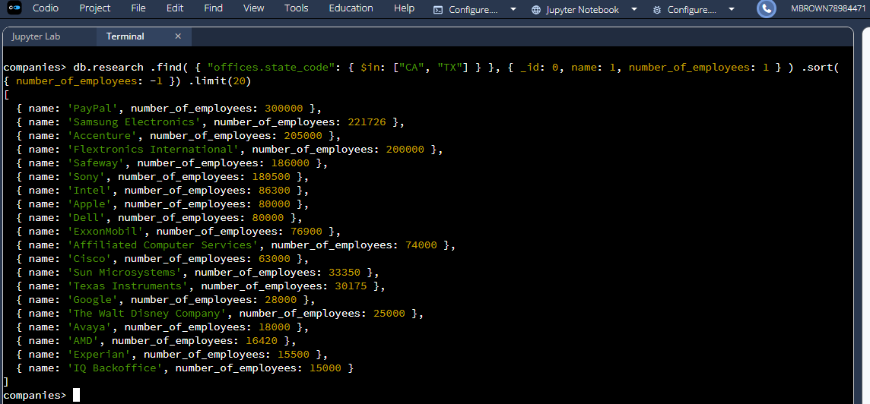

- Design and implement a MongoDB aggregation pipeline.
- $match (USA): filters to companies that have offices in the U.S.
- $unwind "$offices": “explodes” the offices array so each office counts individually.
  - The $unwind stage is critical because companies may have offices in multiple states. Without unwinding, MongoDB would treat the offices array as a single document rather than counting each office individually. The pipeline ensures accurate counting of all U.S. offices across different states.
- second $match (USA): ensures you only count U.S. offices after unwinding.
- $group by state_code: groups all offices by state and adds them up with $sum: 1.
- $sort: orders the results (I used most-to-least offices).
